CS222 Exam 1 Name ___________________________________

This take-home exam is open-book and open notes.

You may use:

* Lab PowerPoint slides.
* Course notes, labs, assignments from the course website.
* Code you’ve written.
* W3 Schools
* Chrome and Chrome Dev Tools for testing
* Atom and/or Sublime to build your code files.

**You may not discuss questions and answers with any other individual.**

**You may grab online images to test your work.**

General instructions

1. The bulk of this exam requires that you build threebasic web pages.
2. In addition to the web pages, you will need to submit a Word document providing UNIX commands for problem 1.
3. Each web page you buildwill require two code documents: HTM and CSS
4. All web pages must be submitted to Moodle and given names such as **page1.html**, **style1.css**, **page2.html**, **style2.css**, etc.
5. Files must be submitted to Moodle by midnight on February 9th.

Problem 1: Basic UNIX Commands

Enter the basic UNIX commands for each of the following tasks.

1. Change directory to access your desktop. _cd____________________________________________
2. List the files and directories on your desktop. _ls____________________________________________
3. Connect to your web server __**sftp [username]@[host domain name]**____
4. Change to the public_html directory. _cd public_html______________________________
5. Change to binary mode. __bin_______________________
6. Upload the file “image.png”. ___put [“image.png”]_______________________

Problem 2: Write the HTML5 and CSS code necessary to recreate the following web page rendered by Chrome.

Your final code should pass the W3C validators.

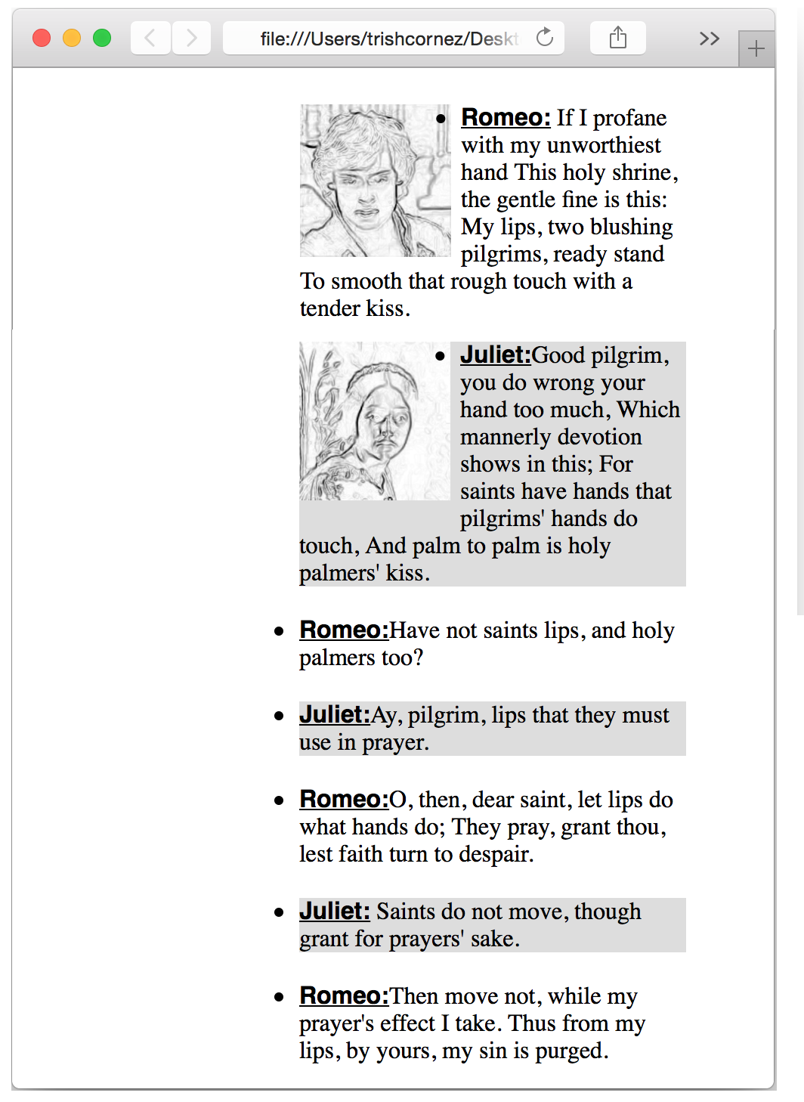

Problem 3: Examine the webpage mockup shown below. Ten additional webpage details are provided (see the next page). Create an optimal structure for this website using HTML5. Construct all necessary style rules in CSS. Make sure that your page matches the mockup using Chrome.

Detail 2: Wrap the content of the webpage in a dotted border with curved edges. Add a margin of 20pixels around the content. Set the background color of the content area as#c6dab2.

Detail 1: Use a fixed width of 1200 pixels for the webpage.

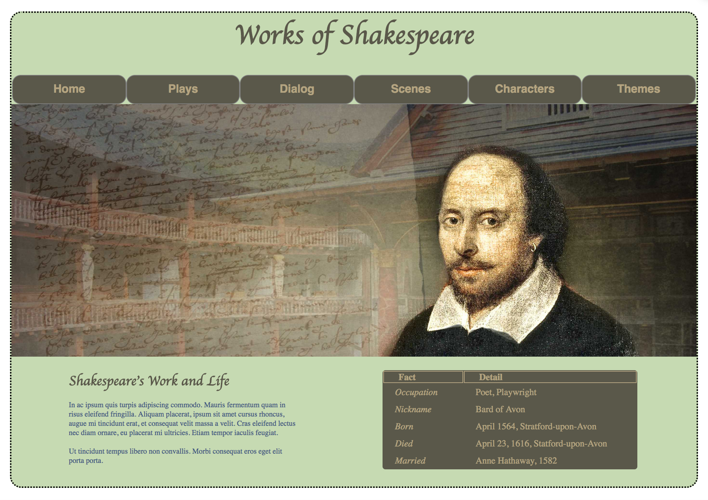

Detail 3: The main title that appears on the page should use a header tag <h1>. The text should have a color set to #5a584a, the font is cursive with a size of 48 pixels, and the alignment should be centered.



Detail 6: Specify a rollover link (hover) in orange. Use a grey color for a normal link.

Detail 5: Menu items compute the correct width.Use a **border radius** of 15 pixels andan interior color of #5a584a. Write the appropriate style rule(s) to ensure that text appears in the middle of the button in a bold font weight in Helvetica.

Detail 4: The menu bar must have a width of 1200 pixels.



Detail 7: Set the width of the image to 1200 pixels.

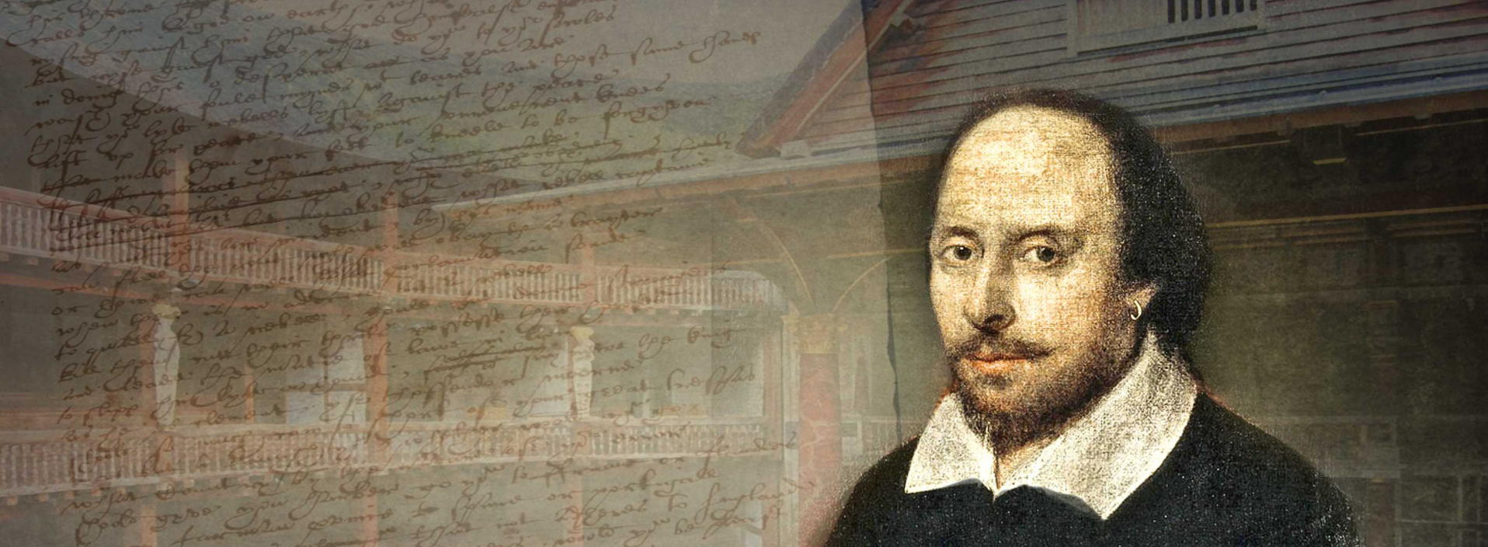

Detail 8: The information elements of the webpage should appear side-by-side, as shown below. The left side has a width of 400 pixels and the right side has a width of 500 pixels. Use margin and padding settings to position them so they appear similar to the image below.

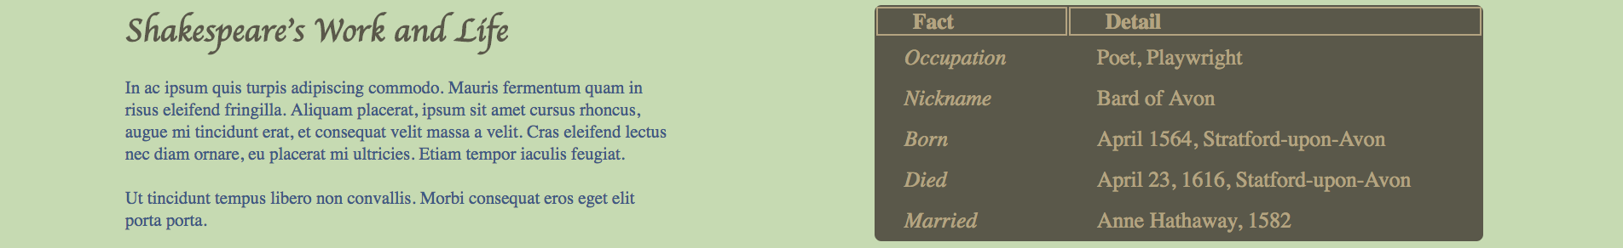

Detail 10: The table in this section has a background-color of #5a584a. The width of the first column is 100 pixels. The width of the second column is 250 pixels. The color of the text is #b4a481.

Detail 9: The title that appears on the section should use a header tag <h1>. The text should have a color set to #5a584a with a cursive font– same as the main page title. The size of this title should be 24 pixels. The paragraph below the title should have a smaller font size.

Problem 4:Implement a responsive framework using CSS.

Build the website shown below.

When the screen size is reduced to 580px, the row elements should be displayed linearly and occupy 100% of the screen width.

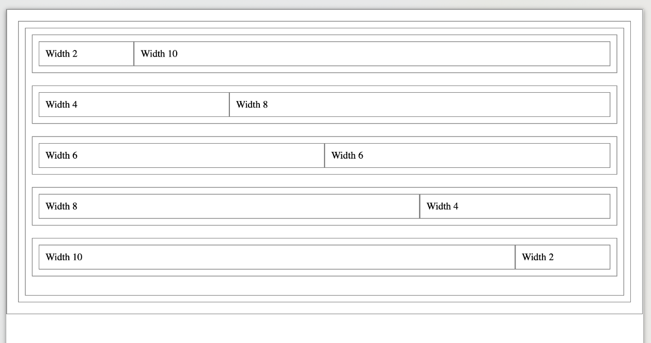

Test your media query by reducing the size of your browser window.

